**Phase 4: Process Automation (Admin)**

**Validation Rules**

Ensure data accuracy and prevent bad entries.

* **Donation Amount > 0** → Block negative or zero donations.
* **Email Required for Donor** → Donor record must have a valid email.
* **Campaign End Date > Start Date** → Prevent invalid campaign setup.
* **Beneficiary Age > 0** (if Type = Individual).

**Workflow Rules**

Automated simple field updates & alerts.

* **Donation Status = Completed** → Send **email alert** to donor with thank-you note.
* **Campaign Goal Reached** → Update Campaign Status to “Completed”.
* **Badge Earned** → Notify NGO staff when a donor reaches a new badge level.

**Process Builder**

Complex, conditional automation (but keep light since Flow is future-proof).

* **Recurring Donations** → Auto-generate next month’s donation record if donor opted for recurring.
* **Donor Loyalty Points** → Add points automatically based on donation amount (e.g., ₹1000 = 10 points).
* **High Value Donation (₹50,000+)** → Notify NGO Manager + create follow-up task for personal acknowledgment.

**Approval Process**

Formal approvals are used where human decision is required.

* **Refund Requests** → Donor requests refund → goes to NGO Manager for approval.
* **Large Campaign Proposals (> ₹5,00,000 goal)** → Requires Admin approval before going live.

**Flow Builder**

Most powerful automation tool (replacing Workflow/Process Builder gradually).  
Types of flows used:

1. **Record-Triggered Flow**
   * When **Donation is created with Status = Completed** →
     + Update Donor’s Total Contributions.
     + Update Campaign’s Amount Raised.
     + Check if Donor qualifies for a new Badge → Assign automatically.
2. **Screen Flow**
   * **Donor Portal Flow** → Donors can select campaigns, beneficiaries, and add to their **Impact Cart** before confirming donation.
   * **NGO Staff Flow** → Simplified UI for quickly adding new Beneficiaries.
3. **Scheduled Flow**
   * Weekly → Send donors a **consolidated donation summary**.
   * Monthly → Send NGO staff a report of campaigns nearing deadlines.
4. **Auto-Launched Flow**
   * Triggered by other processes (e.g., badge assignment).

**Email Alerts**

* **Donation Receipt** → Sent when Donation = Completed.
* **Campaign Update** → Sent to all campaign donors when milestone reached (e.g., 50% funded).
* **Badge Earned** → Congratulatory email with digital badge.

**Field Updates**

* Update **Donor Loyalty Points** on donation save.
* Update **Campaign Status** automatically when goals are reached.
* Set **Refund Status** to “Pending Manager Approval” when donor initiates request.

**Tasks**

* Assign follow-up task to NGO Staff when a new Beneficiary is added (verify details).
* Assign donor relationship manager task when a **major donor (>₹50k)** contributes.

**Custom Notifications**

* **Push Notification to NGO Staff** when a new large donation is made.
* **Push Notification to Donor** (via Experience Cloud app) when their donation is successfully received.
* **Internal Alert** for Admin when suspicious donation patterns (multiple failed attempts) occur.

**Screenshots:**

**Validation rules**

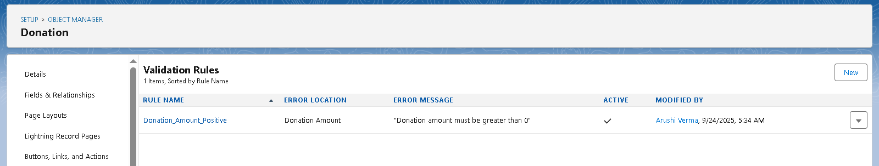 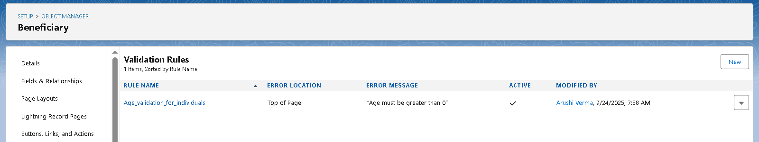 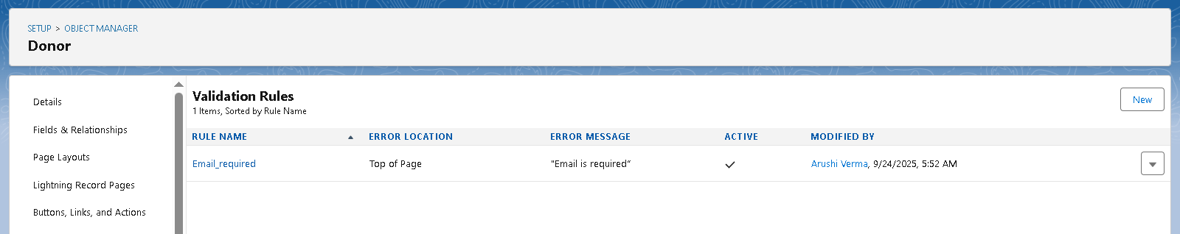

**Work Flows**

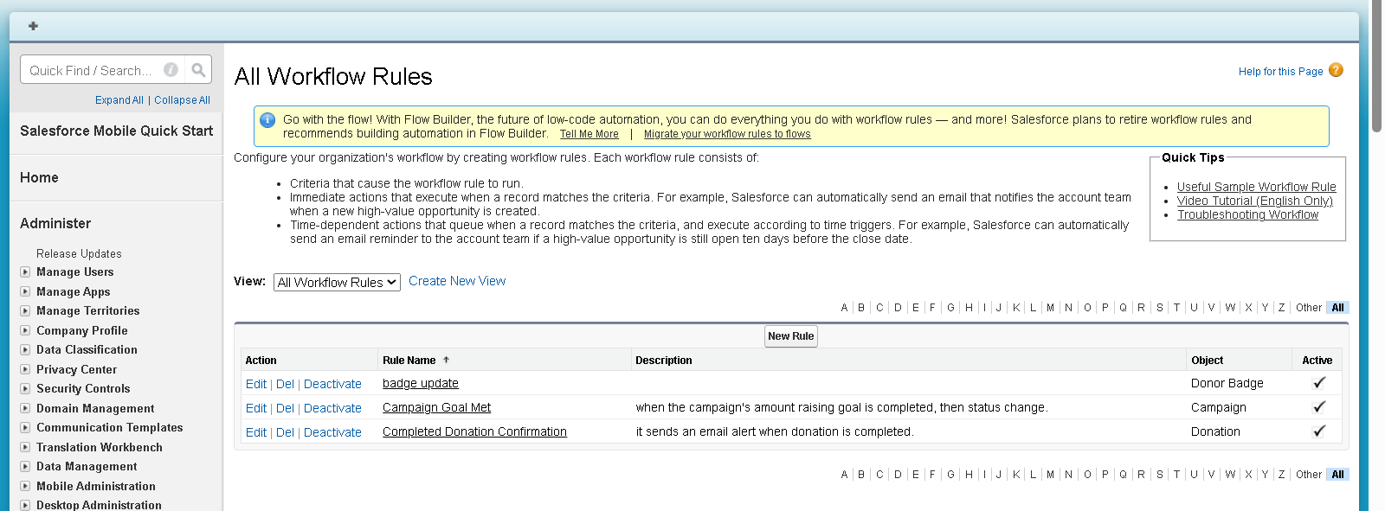 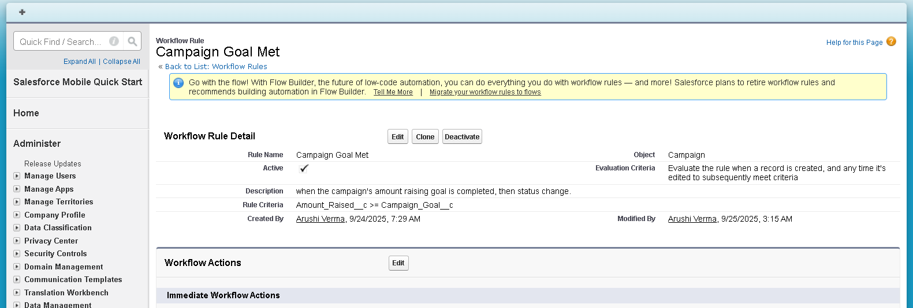

**Approval Process**

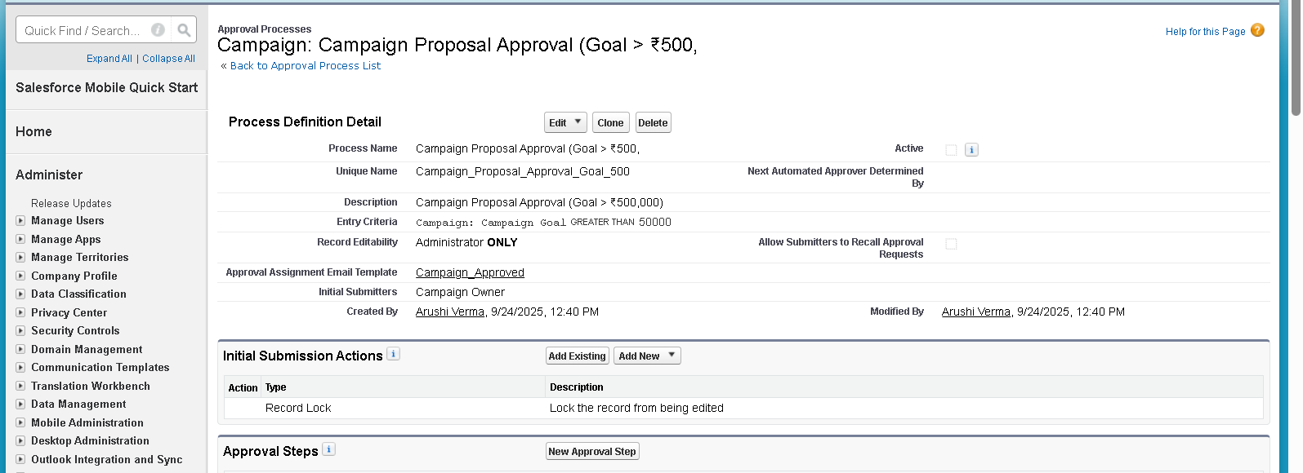

**Flow**

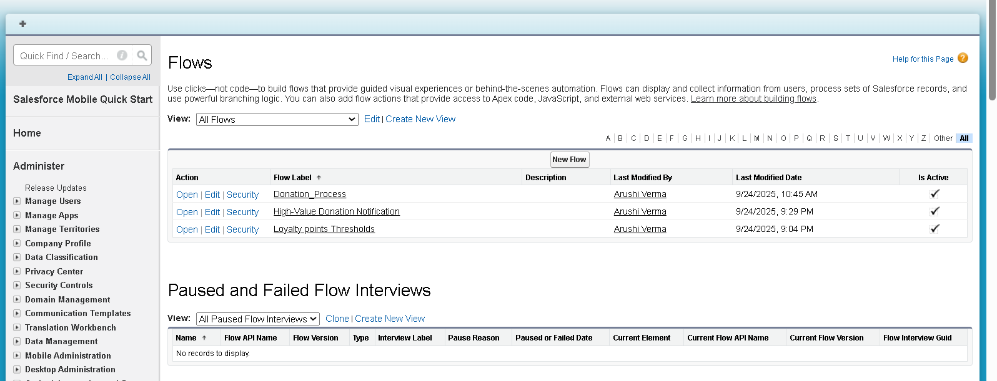

**Email Alerts**

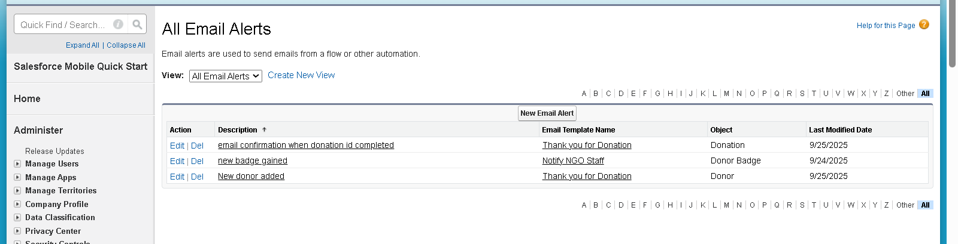

**Flow builder**